Practical - 7
Practical Title: Rendering External JSON Data using Fetch API, Search and Filter

Problem Definition : Process submitted registration/contact form data using PHP. Validate and sanitize inputs on the server side and store records in CSV or JSON file format. Display success/error messages.

Theory
1. Is the form submitted using POST?
Yes, the form is submitted using the POST method, which keeps the form data out of the URL.

2. Are inputs validated and sanitized server side?
Yes, the inputs are received and can be validated and sanitized on the server side before storing them in the CSV file.

3. Is file writing handled safely?
Yes, file writing is handled safely using fopen(), fputcsv(), and fclose(). The code also checks whether the file was opened successfully.

4. Are success and error responses displayed clearly?
Yes, clear responses are displayed. A success message is shown when the profile is saved, and an error message is displayed if the file cannot be opened.

Evidence of Work (Screenshots):
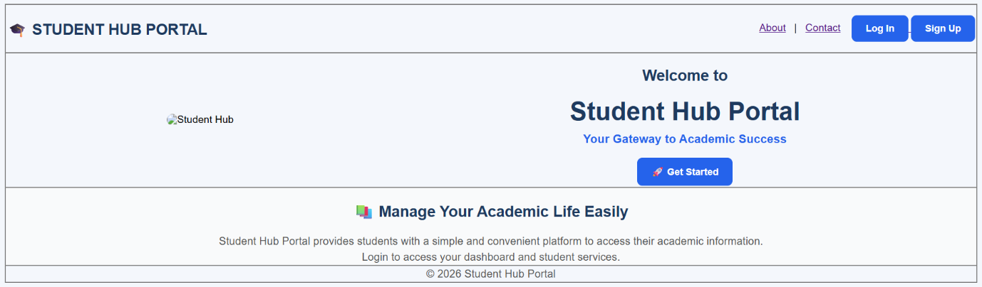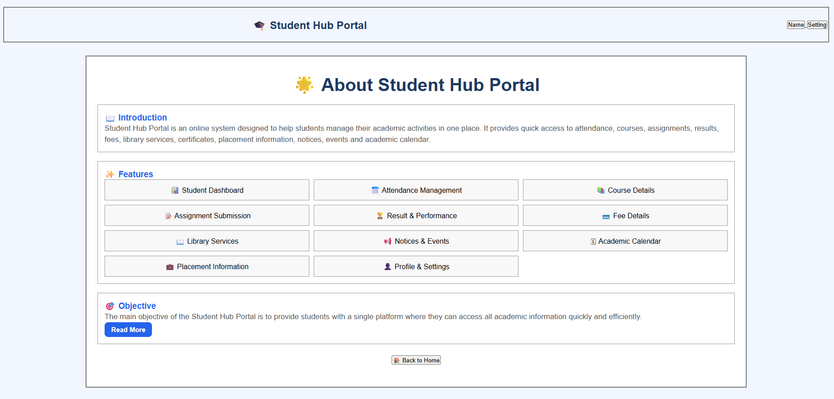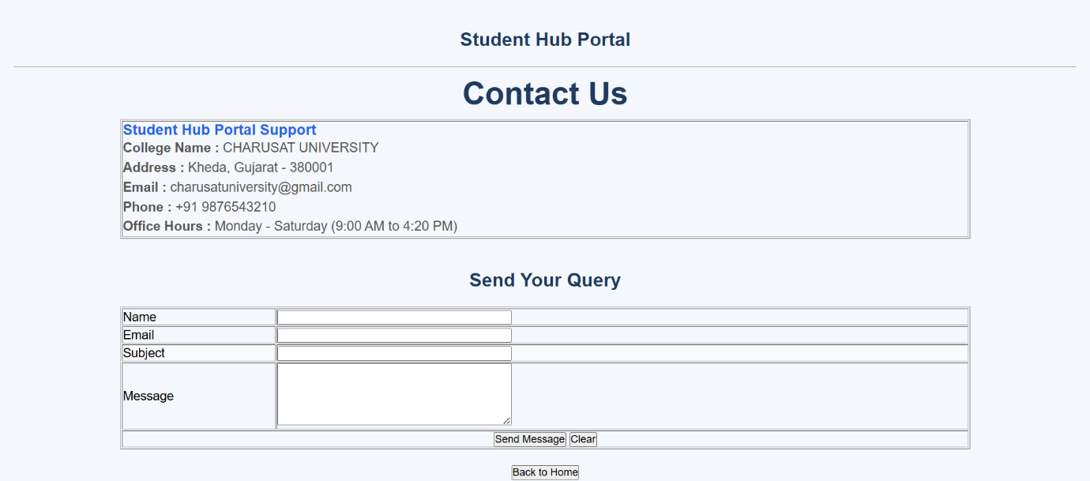
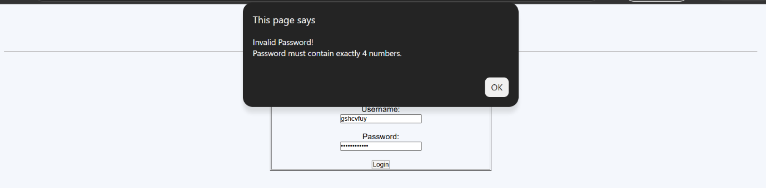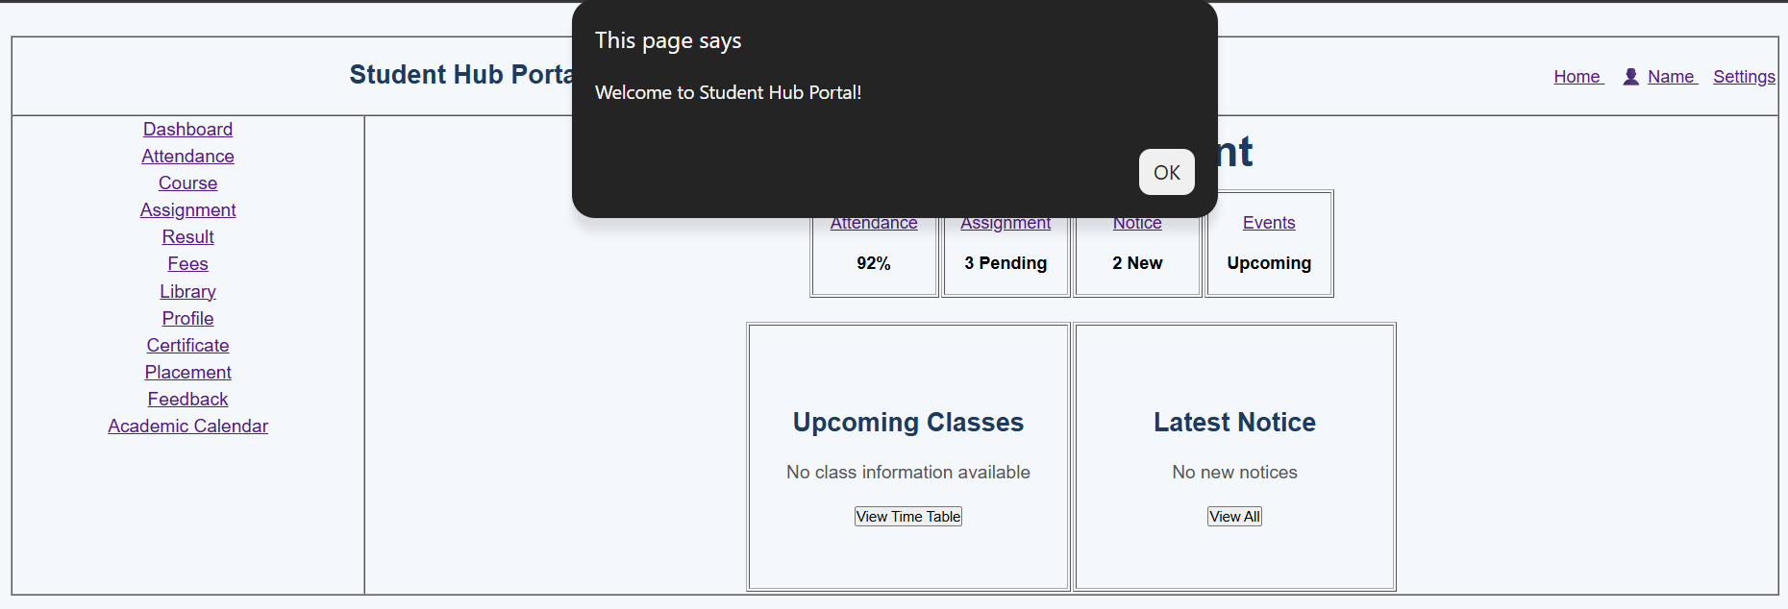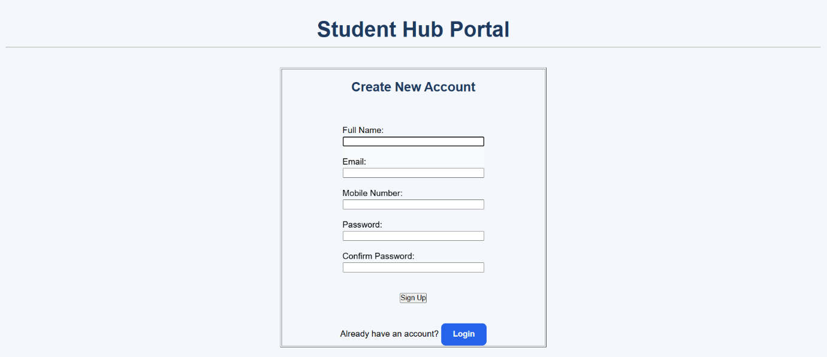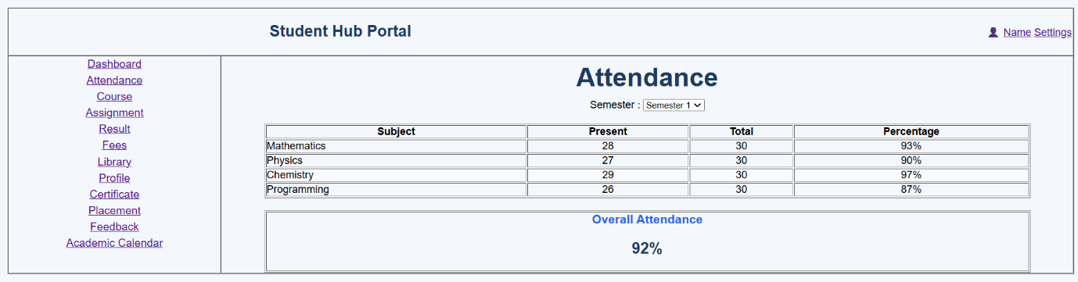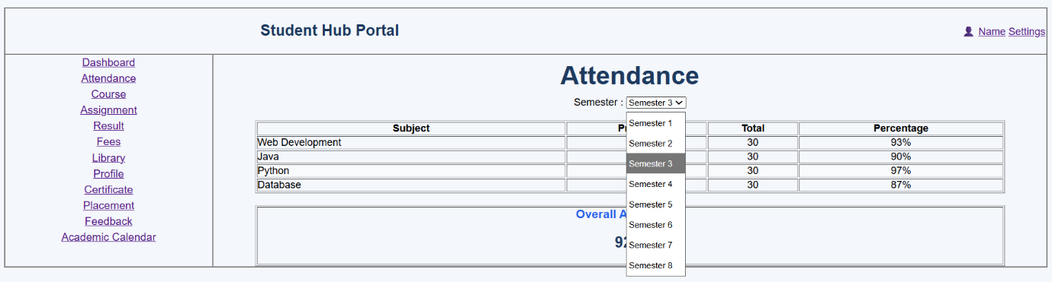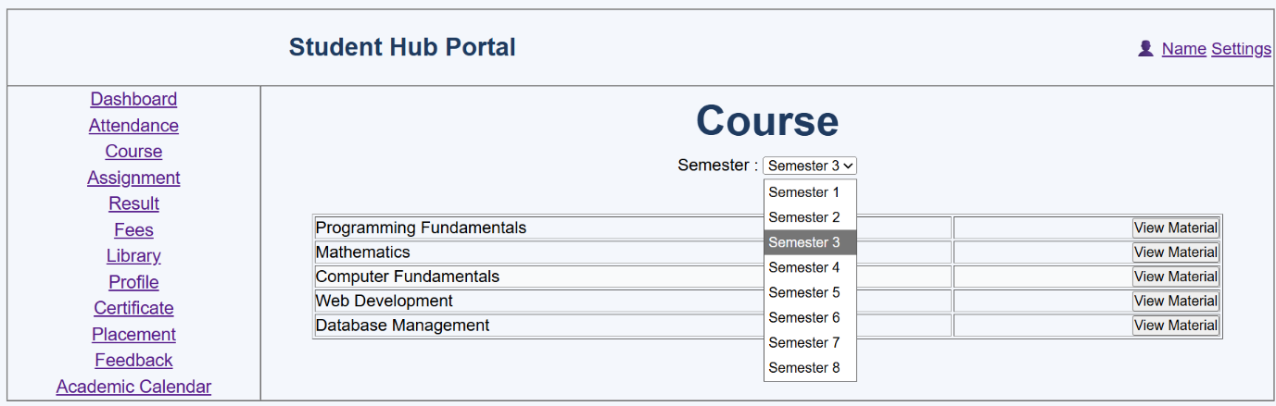
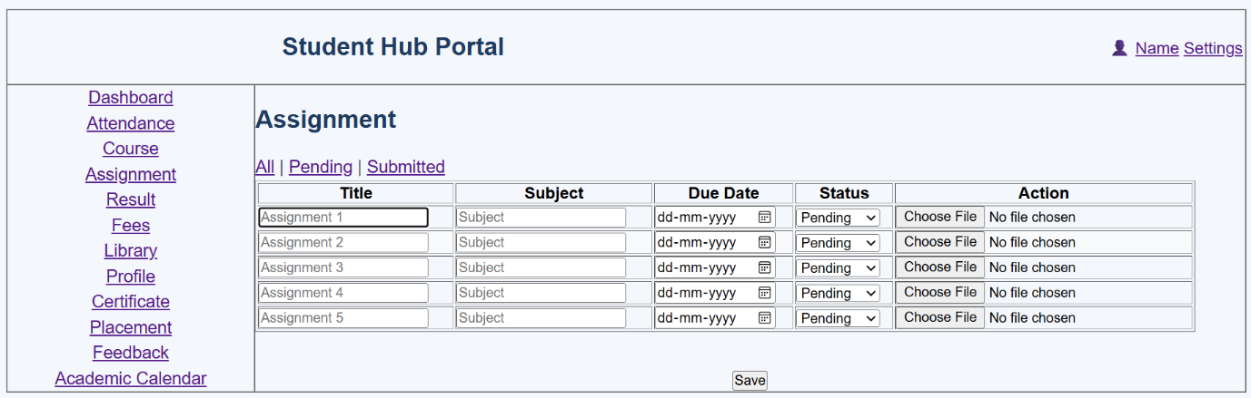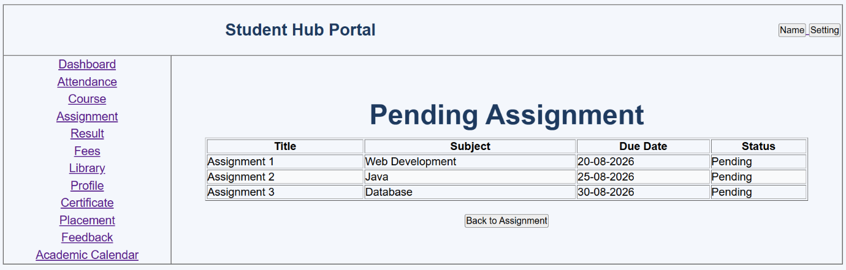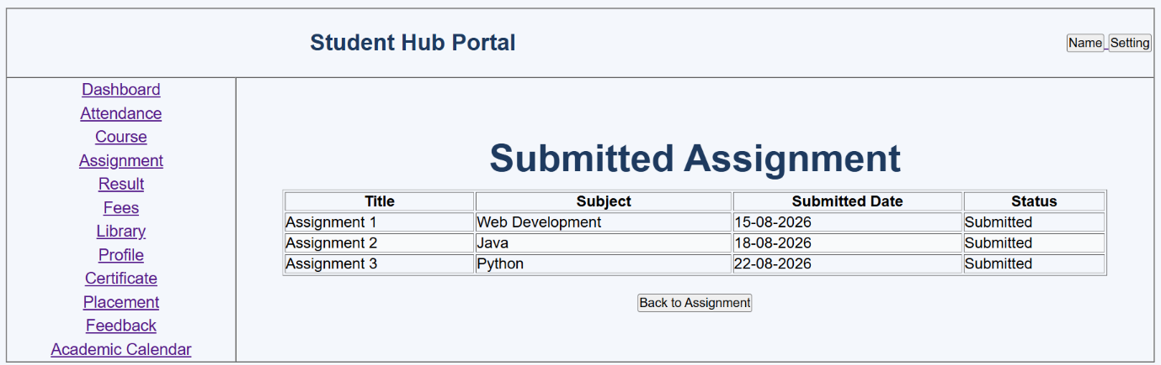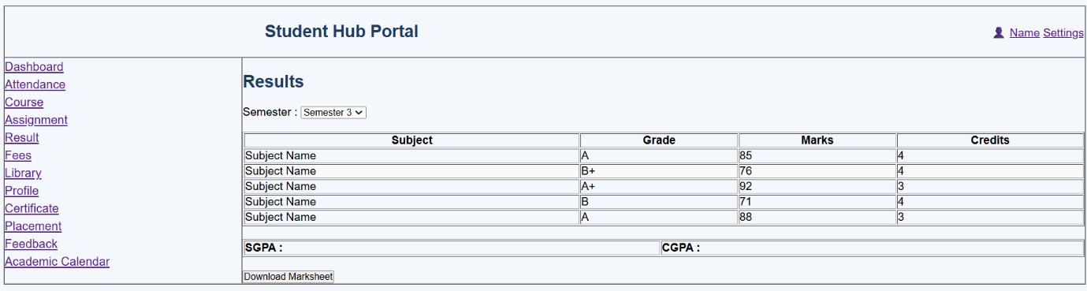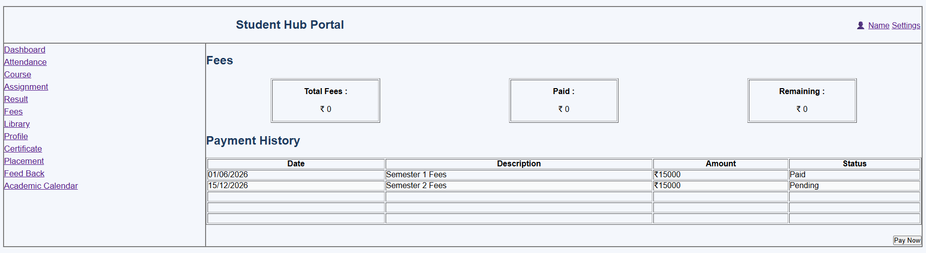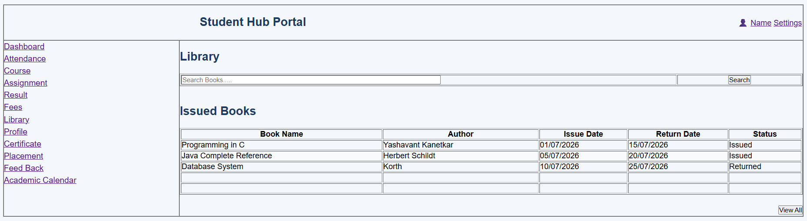
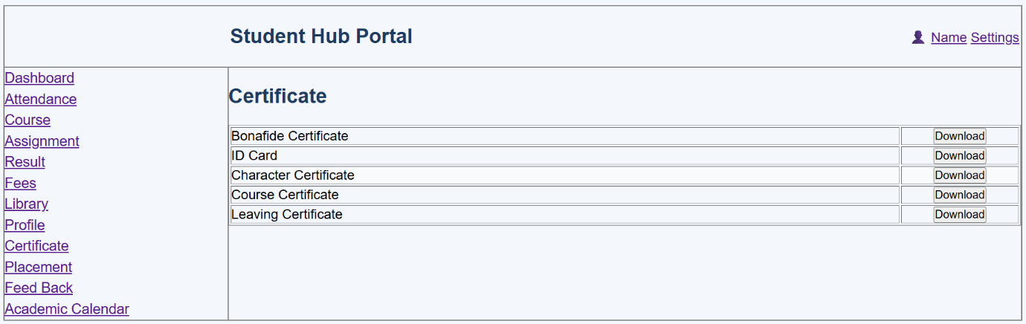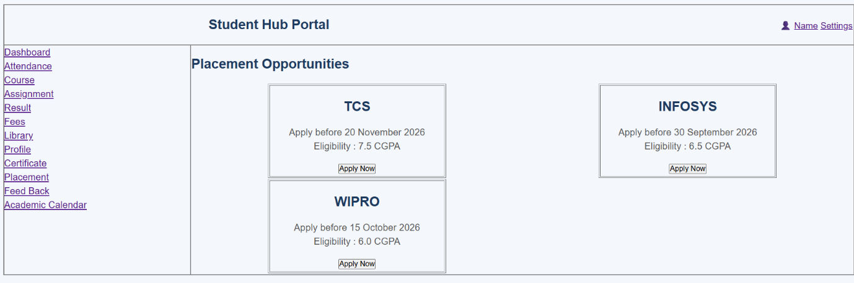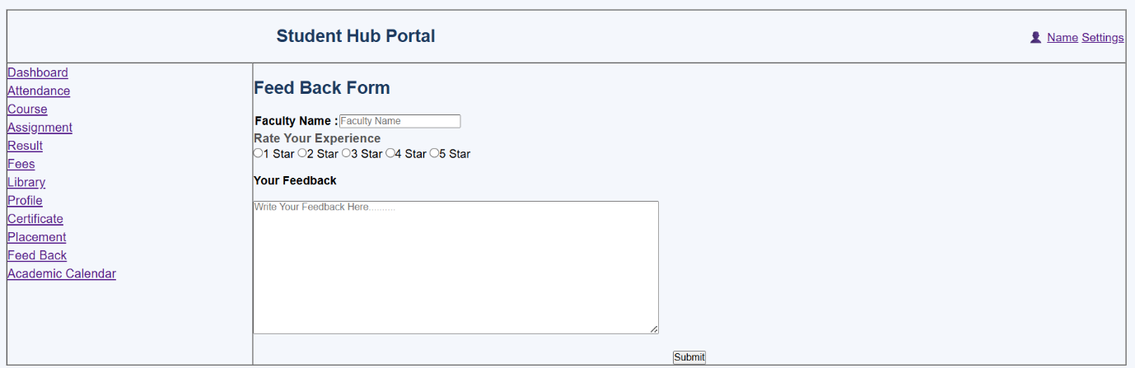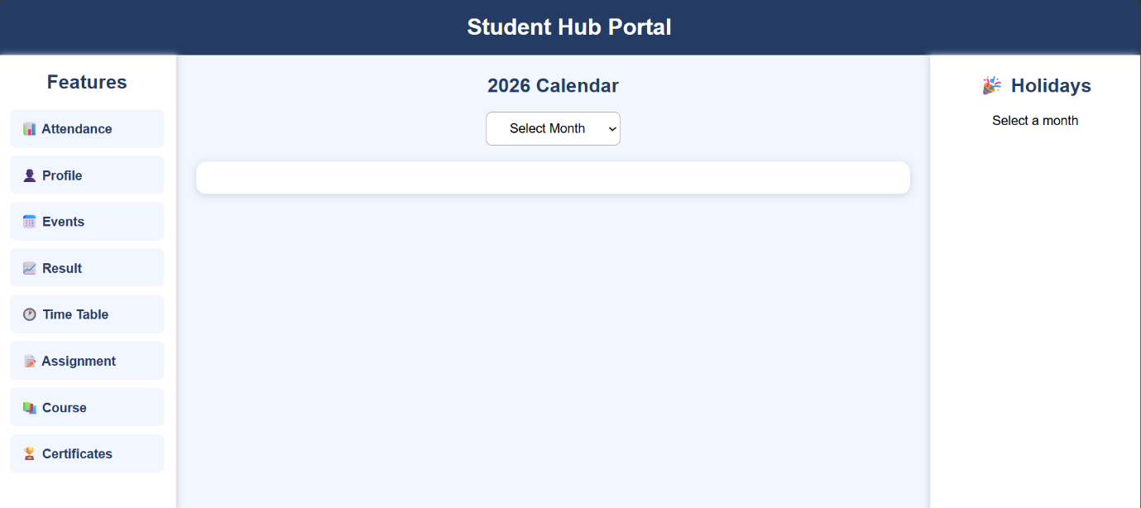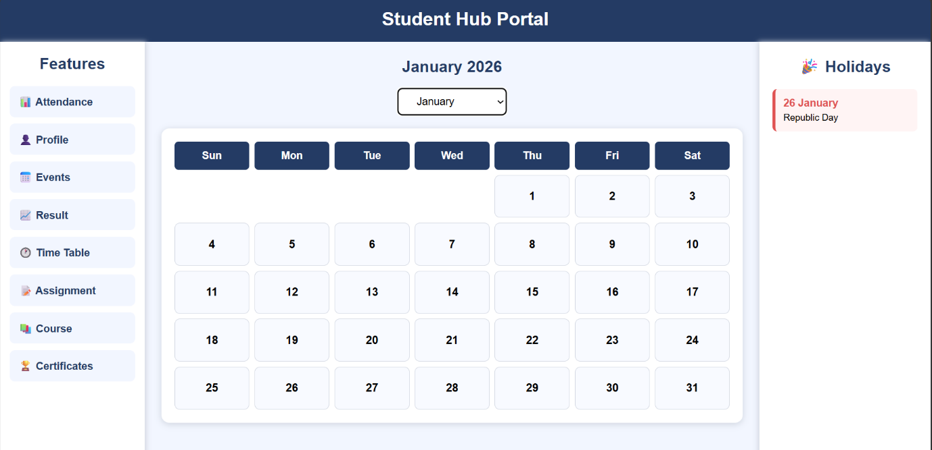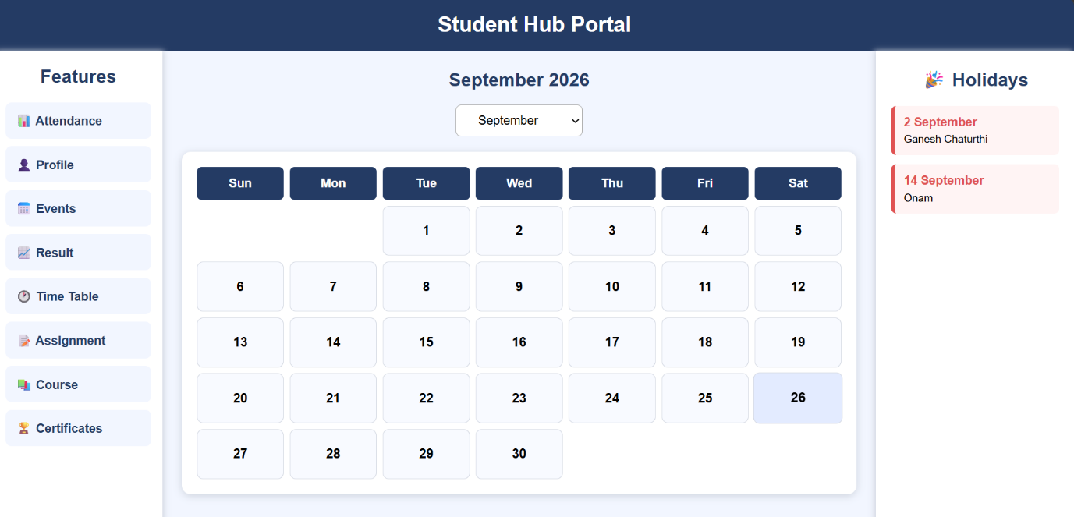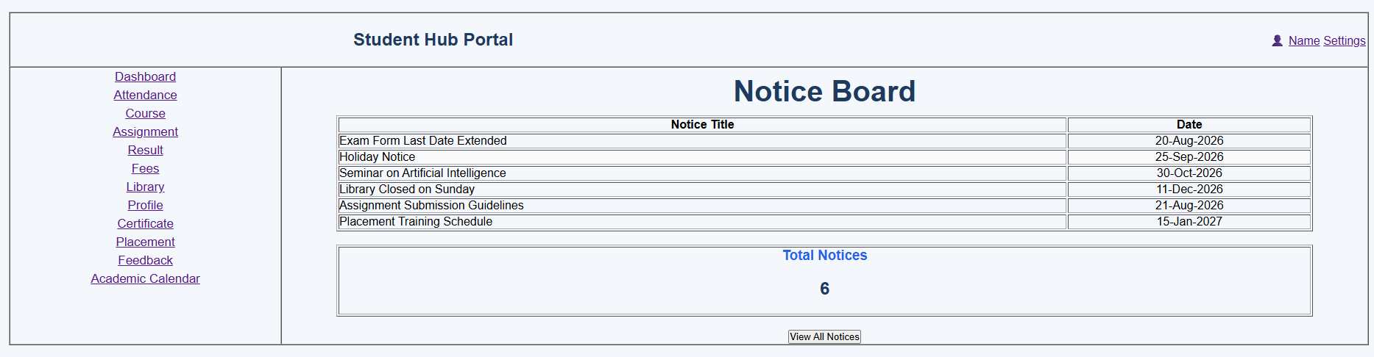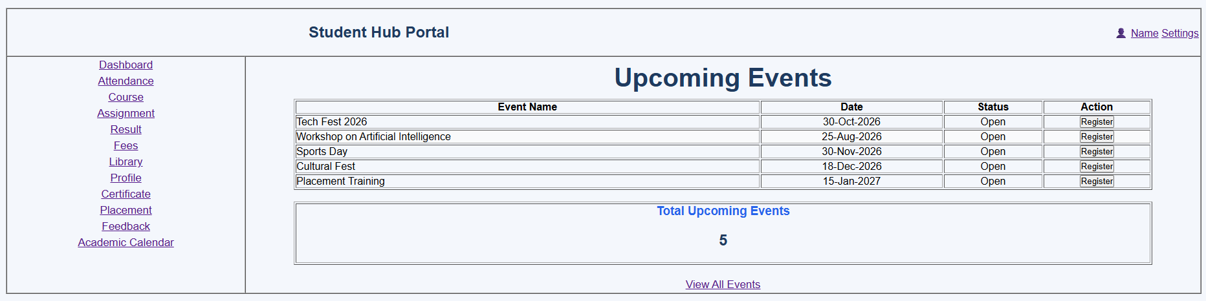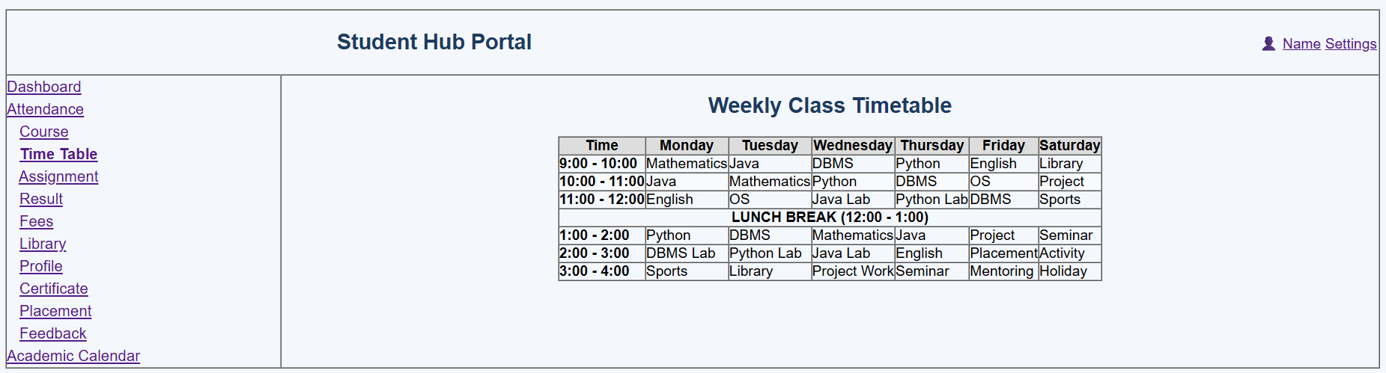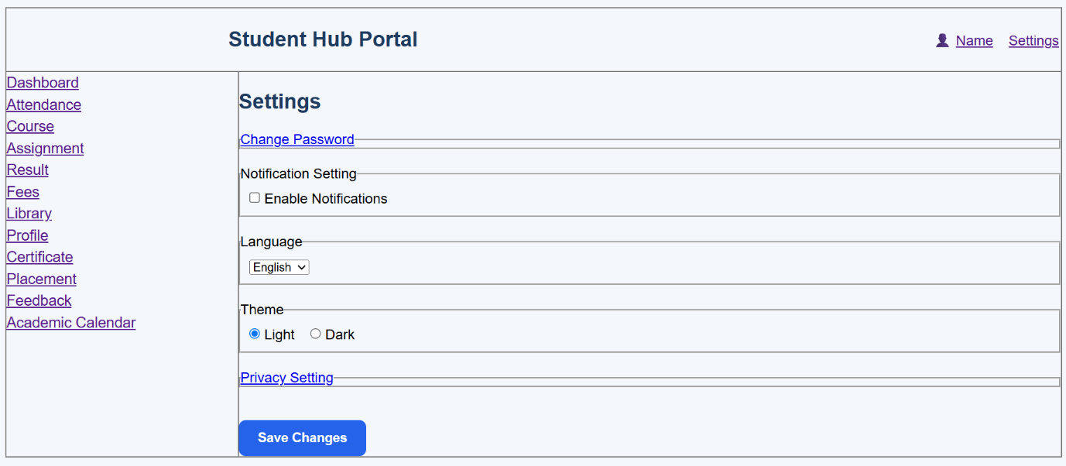
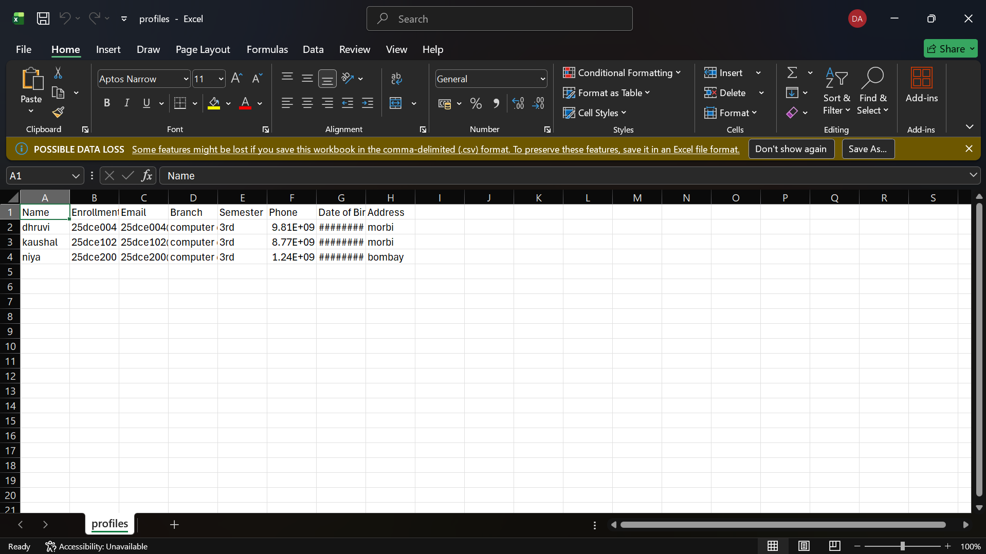
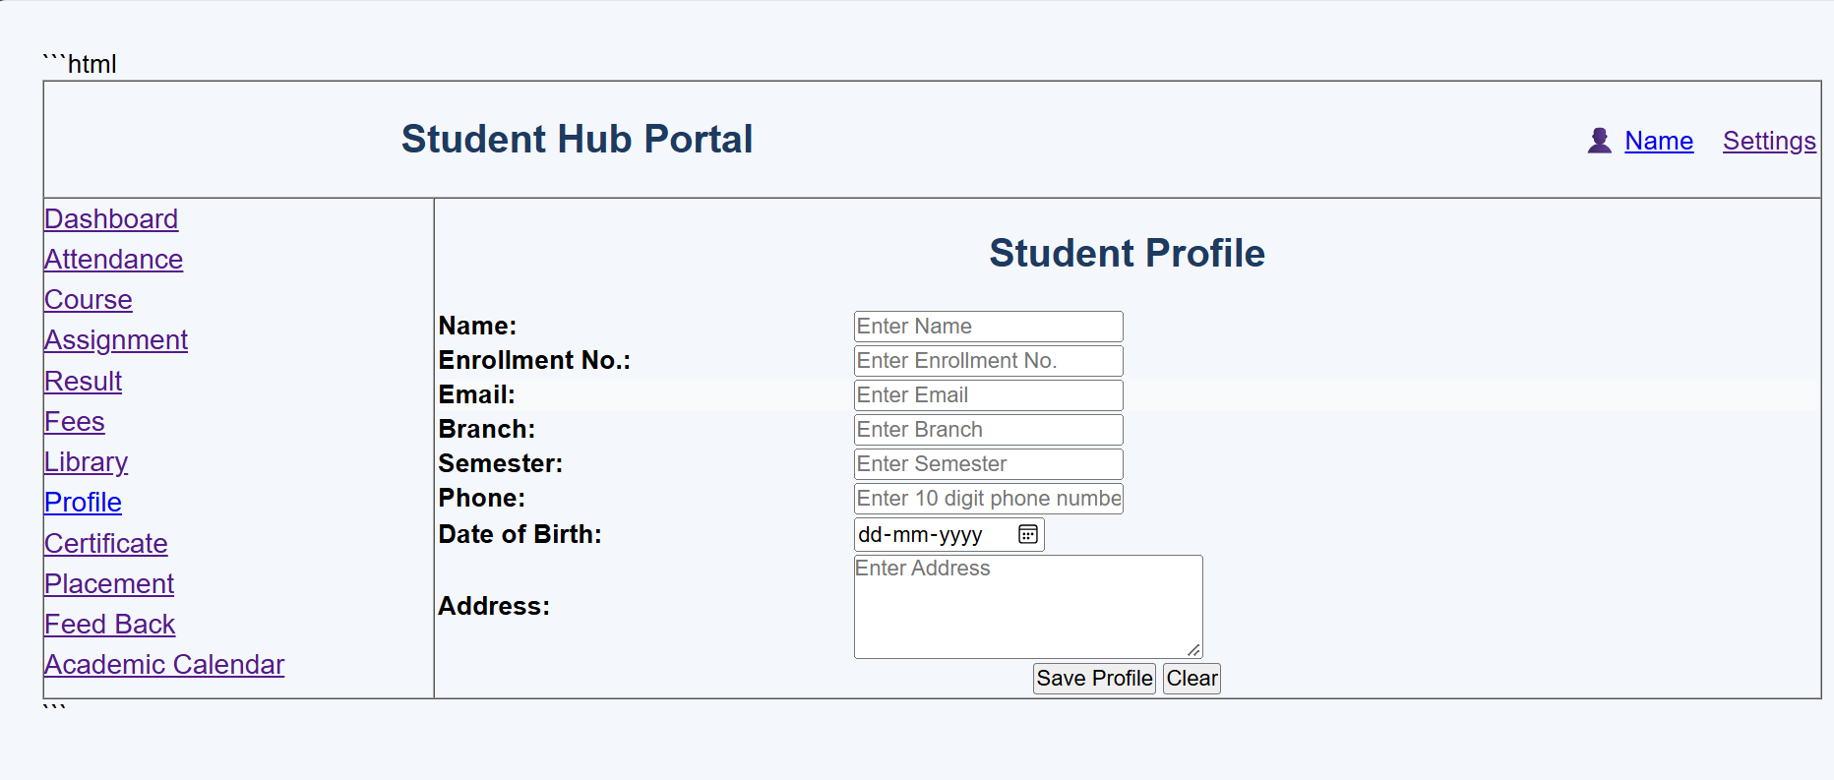
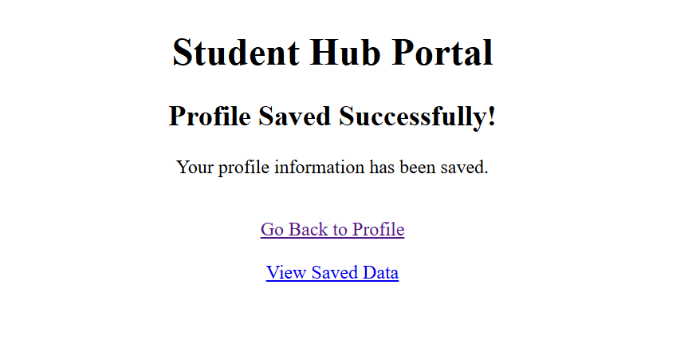

GitHub Repository Link:

https://github.com/Andarpadhruvi1125/Student-Hub-portal.git

C. Challenges Faced: While performing this practical, I faced some challenges in understanding PHP form processing and handling submitted data using the POST method. I also faced difficulty in performing server-side validation and sanitizing the input fields correctly. Another challenge was creating and writing student details into the CSV file and checking the correct file path. Debugging file storage and displaying proper success or error messages also required some effort. By testing and correcting the code, I was able to successfully complete the practical.
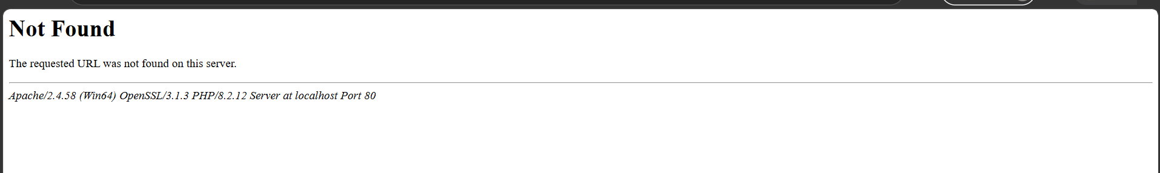

D. Learning Outcomes: After completing this practical, I learned how to process HTML form data using PHP and the POST method. I understood how to perform server-side validation and sanitization of user inputs. I also learned how to create, write, and store submitted records in a CSV file using PHP. This practical helped me understand basic backend form processing, file handling, and displaying appropriate success and error messages to users.

Faculty Remarks: (Keep this blank for faculty)

